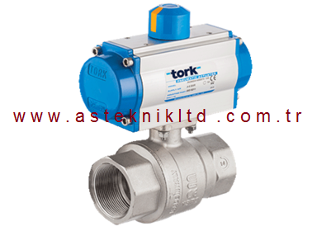

ÜRÜN ÖZELLİKLERİ

|  |
| --- |
| **TORK-PAV 901.DA Çift etkili pnömatik aktüatörlü pirinç küresel vana** |

|  |  |  |  |  |  |
| --- | --- | --- | --- | --- | --- |
| **vana ölçü** | **sipariş tip no** | **yol ad.** | **basınç** | **sıcaklık** | **ISO bağ. flanş** |
| 1/2" | TORK-PAV901.15DA | 2/2 | 0-40 bar | 0..150 C | F03 |
| 3/4" | TORK-PAV901.20DA | 2/2 | 0-40 bar | 0..150 C | F03 |
| 1" | TORK-PAV901.25DA | 2/2 | 0-40 bar | 0..150 C | F03 /F04 |
| 11/4" | TORK-PAV901.32DA | 2/2 | 0-40 bar | 0..150 C | F04 /F05 |
| 11/2" | TORK-PAV901.40DA | 2/2 | 0-16 bar | 0..150 C | F04 /F05 |
| 2" | TORK-PAV901.50DA | 2/2 | 0-16 bar | 0..150 C | F05 |
| 21/2" | TORK-PAV901.65DA | 2/2 | 0-16 bar | 0..150 C | F05 |

|  |
| --- |
| **TORK-PAV 901.SR Tek etkili pnömatik aktüatörlü pirinç  küresel vana** |

|  |  |  |  |  |  |
| --- | --- | --- | --- | --- | --- |
| **vana ölçü** | **sipariş tip no** | **yol ad.** | **basınç** | **sıcaklık** | **ISO bağ. flanş** |
| 1/2" | TORK-PAV901.15SR | 2/2 | 0-40 bar | 0..150 C | F03 |
| 3/4" | TORK-PAV901.20SR | 2/2 | 0-40 bar | 0..150 C | F03 |
| 1" | TORK-PAV901.25SR | 2/2 | 0-40 bar | 0..150 C | F03 /F04 |
| 11/4" | TORK-PAV901.32SR | 2/2 | 0-40 bar | 0..150 C | F04 /F05 |
| 11/2" | TORK-PAV901.40SR | 2/2 | 0-16 bar | 0..150 C | F04 /F05 |
| 2" | TORK-PAV901.50SR | 2/2 | 0-16 bar | 0..150 C | F05 |
| 21/2" | TORK-PAV901.65SR | 2/2 | 0-16 bar | 0..150 C | F05 |